

**Department of Computer Science & Engineering**

**Lab Final Report**

Course Title: Introduction to Embedded Systems Lab

Course Code: CSE3028, Section-2

**Submitted to**

Mr. Ovishake Sen

Lecturer

Department of Computer Science and Engineering

**Submitted by**

**Name : Ashik Sarker**

**ID : 2018000000125**

**Name : Thamina Akther**

**ID : 2018000000149**

**Name : Afroza Akter Monisha**

**ID : 2018000000082**

**Date of Submission: 10th October, 2022**

**Project Title: Arduino RADAR Model for Distance & Angle Finding using Ultrasonic Sensor**

**Project Documentation, Overview**:

In this project, we have designed Arduino RADAR Model using Ultrasonic Sensor for Detection & Ranging. RADAR is an object detection system that uses radio waves to identify the range, altitude, direction, and speed of the objects. The radar antenna transmits radio wave pulses that bounce off any object in its path. The object returns a portion of the wave received by the receiver which is in line of sight with the transmitter.

This Arduino RADAR project aims to achieve a radar system prototype based on an Arduino board, capable of detecting stationary and moving objects.

**Components:**

* Arduino uno

* Ultrasonic sensor

* Servo Motor

**Curcuit Diagram:**

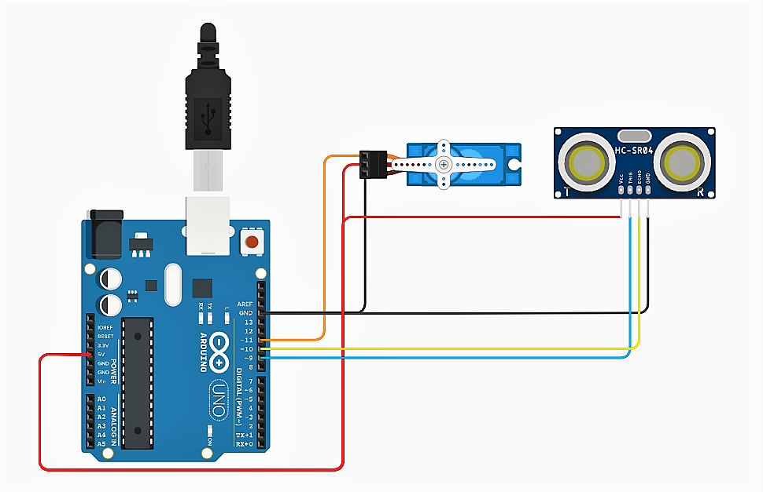

**Coding Part of this project :**

#include <Servo.h>.

const int trigPin = 10;

const int echoPin = 11;

long duration;

int distance;

Servo myServo;

void setup() {

pinMode(trigPin, OUTPUT);

pinMode(echoPin, INPUT);

Serial.begin(9600);

myServo.attach(12);

}

void loop() {

for(int i=15;i<=165;i++){

myServo.write(i);

delay(30);

distance = calculateDistance();

Serial.print(i);

Serial.print(",");

Serial.print(distance);

Serial.print(".");

}

for(int i=165;i>15;i--){

myServo.write(i);

delay(30);

distance = calculateDistance();

Serial.print(i);

Serial.print(",");

Serial.print(distance);

Serial.print(".");

}

}

int calculateDistance(){

digitalWrite(trigPin, LOW);

delayMicroseconds(2);

digitalWrite(trigPin, HIGH);

delayMicroseconds(10);

digitalWrite(trigPin, LOW);

duration = pulseIn(echoPin, HIGH);

distance= duration*0.034/2;

return distance;

}